Unit XIII Assignment II: Dealing with Faults

By Nathan Windisch

Contents

Introduction 2

PII – Troubleshooting with Hardware & Software to Solve Problems 3

PIII – Identification of Sources & Remedies of Faults 4

PIV – Application of Fault Remedies to Solve Issues 5

PV – Good Working Practices 6

PVI – Recording Fault Diagnosis & Repair Activities 7

MI – Effective Communication with Users During Fault Diagnosis 11

MII – Justification of Appropriate Remedies During Fault Diagnosis 15

MIII – Maintaining Data Security & Integrity When Applying Remedies 16

DII – Comparing Hardware & Software Troubleshooting Tools 17

Bibliography 18

# Introduction

In this assignment I will talk about the usage of both hardware and software tools when used to troubleshoot and solve problems in a technical environment. I will identify different sources of faults and provide solutions for them, and explain how I came across these solutions. I will discuss how to apply these solutions and I will also discuss the need for good working practices and a safe workplace environment when performing system repair. I shall also provide examples of what I have done to discover and attempt to solve critical issues in four separate machines. A transcript of what my colleagues and I have said when working on these machines will also be given, to show how we work together to solve critical problems. I will also appropriate and justify my methods that I have used when repairing these systems. I shall also touch on data security and integrity of systems and why these are so important in both a general scenario and a more specific scenario tailored to the different tasks that we have completed in this unit. I shall also give my option on different hardware and software tools that I have used, and which one I would recommend if I had to choose either one or the other. I shall list the pros and contras off the aforementioned tools.

# PII – Troubleshooting with Hardware & Software to Solve Problems

We used an ESD mat, a wristband, a screwdriver and a voltmeter to troubleshoot the issues on the first machine that we analysed. Again, as the machine could not get past POST, we could not use any software tools. The source of the error code 99 was the power supply failure that was described earlier. This meant that we had to send the computer back to Dell to get it fixed as a broken power supply can be hazardous. The only way to solve the issues presented to us was to send it to Dell to get it fixed; it was out of our hands. **<ESDMatPictureHere>**

When we troubleshot the second machine was the same ESD mat and wristband as before. Other than that, there were no more hardware issues so we did not require any more physical tools to perform any more procedures. As the second machine did not have an operating system, we decided to use a Windows Install disk to get an operating system on the machine. We chose Windows 7 as we have access to many product keys due to the fact that *I Can Fix It Ltd* has a site licence. **<WristbandPictureHere>**

The third machine was much like the first, we couldn’t get past POST so we only used hardware tools, and the tools that we used was an ESD mat, a wristband, a screwdriver and tweezers, similar to the tools used on the first machine. We finally managed to get it working and we installed Windows 7 on it too. **<ScrewdriverAndTweezersHere>**

We used software to troubleshoot some issues. For one issue we encountered with the second unit, we had to install an operating system to solve the issue of there not being an operating system installed in the first place. This was an easy fix as we already had some spare licence keys and we also had a copy of a Windows 7 install on a memory stick, read to be installed. **<Unit2WindowsInstallImagesHere>**

For an issue that occurred on the second machine we decided to install Malware Bytes as we felt that the default Windows Defender was not good enough an antivirus to defend the machine against some of the more advanced attacks that have been created in recent times, including updated versions of Trojans, difficult to detect Keyloggers and hard to shut down Forkbombs.

# PIII – Identification of Sources & Remedies of Faults

|  |  |  |  |
| --- | --- | --- | --- |
| **Unit Number# and Fault** | **Description of the Fault** | **Remedies Applied** | **Resources** |
| Unit #1: Power Supply failure | When loading up the computer, it did not get past POST and it displayed the error code 99. | We sent the machine back to the manufacturer as we did not have the tools to repair the issues present. | We used <http://google.com/> to see what the error code was and what it meant. |
| Unit #2: PC didn’t boot to an OS | The computer didn’t boot to an operating system | We had to install an operating system manually via a USB drive. | Windows 7 ISO on a USB drive. |
| Unit #3: RAM error | The computer didn’t get past POST and did two beeps, meaning a RAM error. | We refitted the RAM after cleaning it, then we installed an operating system to the system. | Windows 7 ISO on a USB drive. |
| Unit #4: No AntiVirus | There was no AntiVirus installed on the system. We discovered this fault by going to the Control Panel -> Programs -> Programs & Features and seeing that there was no AntiVirus installed. | We installed Malwarebytes from <http://malwarebytes.org/>. We then ran a scan on the computer but it came up clean. | <http://malwarebytes.org/> for the Malwarebytes download. |

# PIV – Application of Fault Remedies to Solve Issues

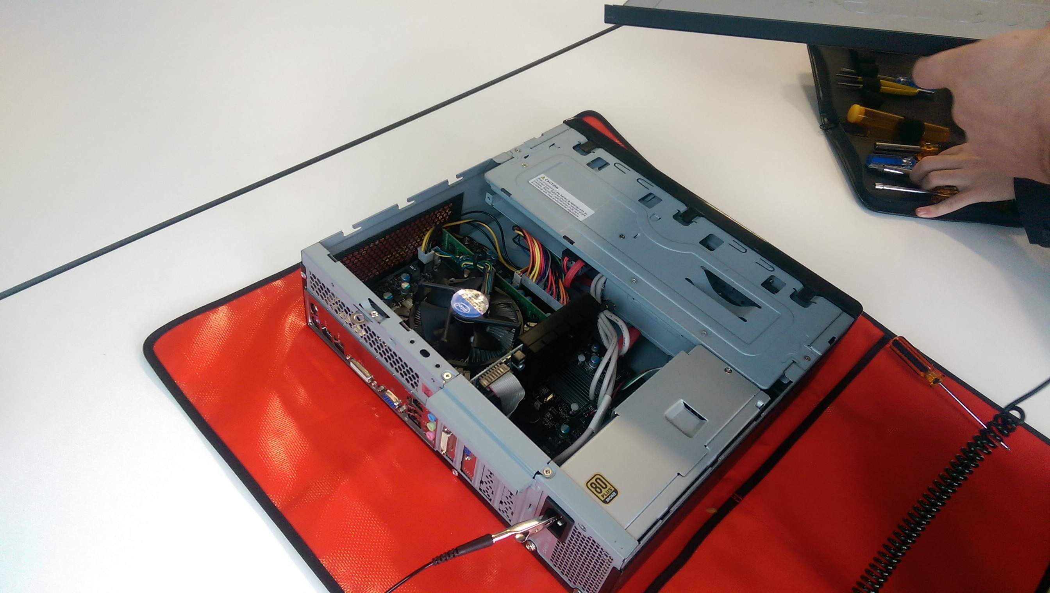

To solve the hardware based issues that were brought to us with the first, second and third units, we used an electrostatic discharge mat that allowed us to access the system without hurting either ourselves or the components inside the computer. We also used the accompanying wristbands to redirect all of our static energy away from the components that we were handling and into the electrostatic discharge mat. For the first system we also used a screwdriver and a voltmeter as we could not get past POST due to a power supply failure that we could not fix. We used a screwdriver and tweezers for the third machine as we had to remove and replace the RAM due to the RAM error it produced when being started up. The fourth unit did not have any hardware faults.

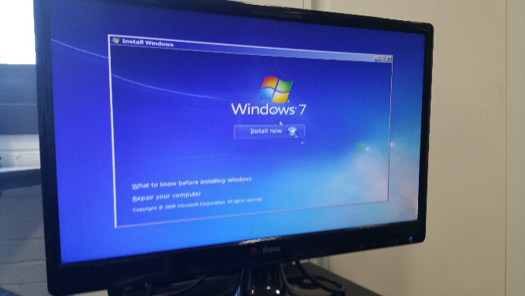To solve the software based issues that were brought to us with the second unit, we used the Windows Installer from the ISO that we had on the USB drive that we found in the cupboard. The following images show Windows being installed on the system.

To solve the software based issues that were brought to us with the fourth unit, we installed Malwarebytes via the Malwarebytes installer that we found on <http://malwarebytes.com/>. We also used Internet Explorer to access this webpage in the first page. The first and third units did not have any software faults.

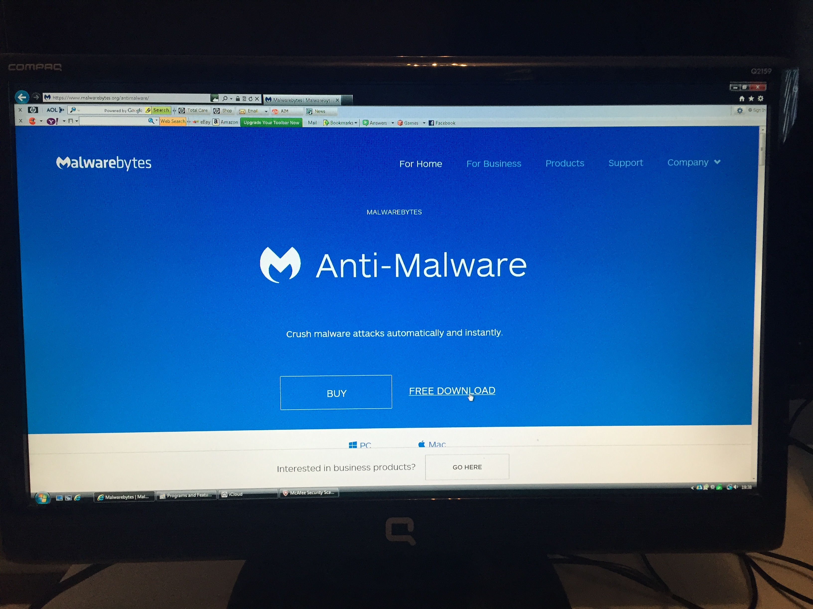

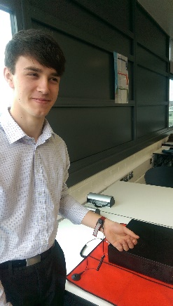The first thing that we did to make sure that we were safe was the removal of our ties and lanyards. This meant that we would not hurt ourselves whilst working on the machines, as the ties and lanyards may get caught on the machinery. If there was a danger in the room our ties and lanyards may slow down our getaway from the area, resulting in physical or psychological damage. Our lanyards and ties may also get caught in the moving parts of the system, meaning that we could get strangled, possibly resulting in death. Our ties and lanyards could also burn if there was a fire, resulting in severe burns if they could not be removed in time.

The second thing that we did was we ensured that the desk was clear from any and all things that could cause both a distraction and an unsafe work environment. This allowed us to work in an environment that would allow a highly safe environment. If the desk was not clear and had sharp objects on it, if we were to fall onto the aforementioned sharp object we may have hurt ourselves, resulting in a less productive and hostile workplace environment.

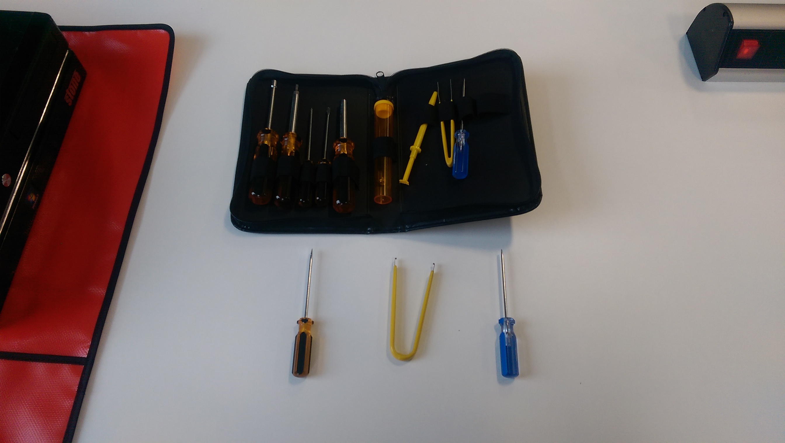

The third thing that we did to ensure that we would be safe during the process of fixing the computers was it use an electrostatic discharge mat and accompanying wristband to prevent electrostatic discharge and to also prevent electric shocks from the mains power caused by touching the metal parts of the computer that were connected to the live cable plugged into the wall socket. If this were the case, we would probably not survive the 3kW that comes from those sockets. Another reason as to why we used an electrostatic discharge mat was to ensure that none of the components inside the machine were broken by the static discharge given out by our bodies.

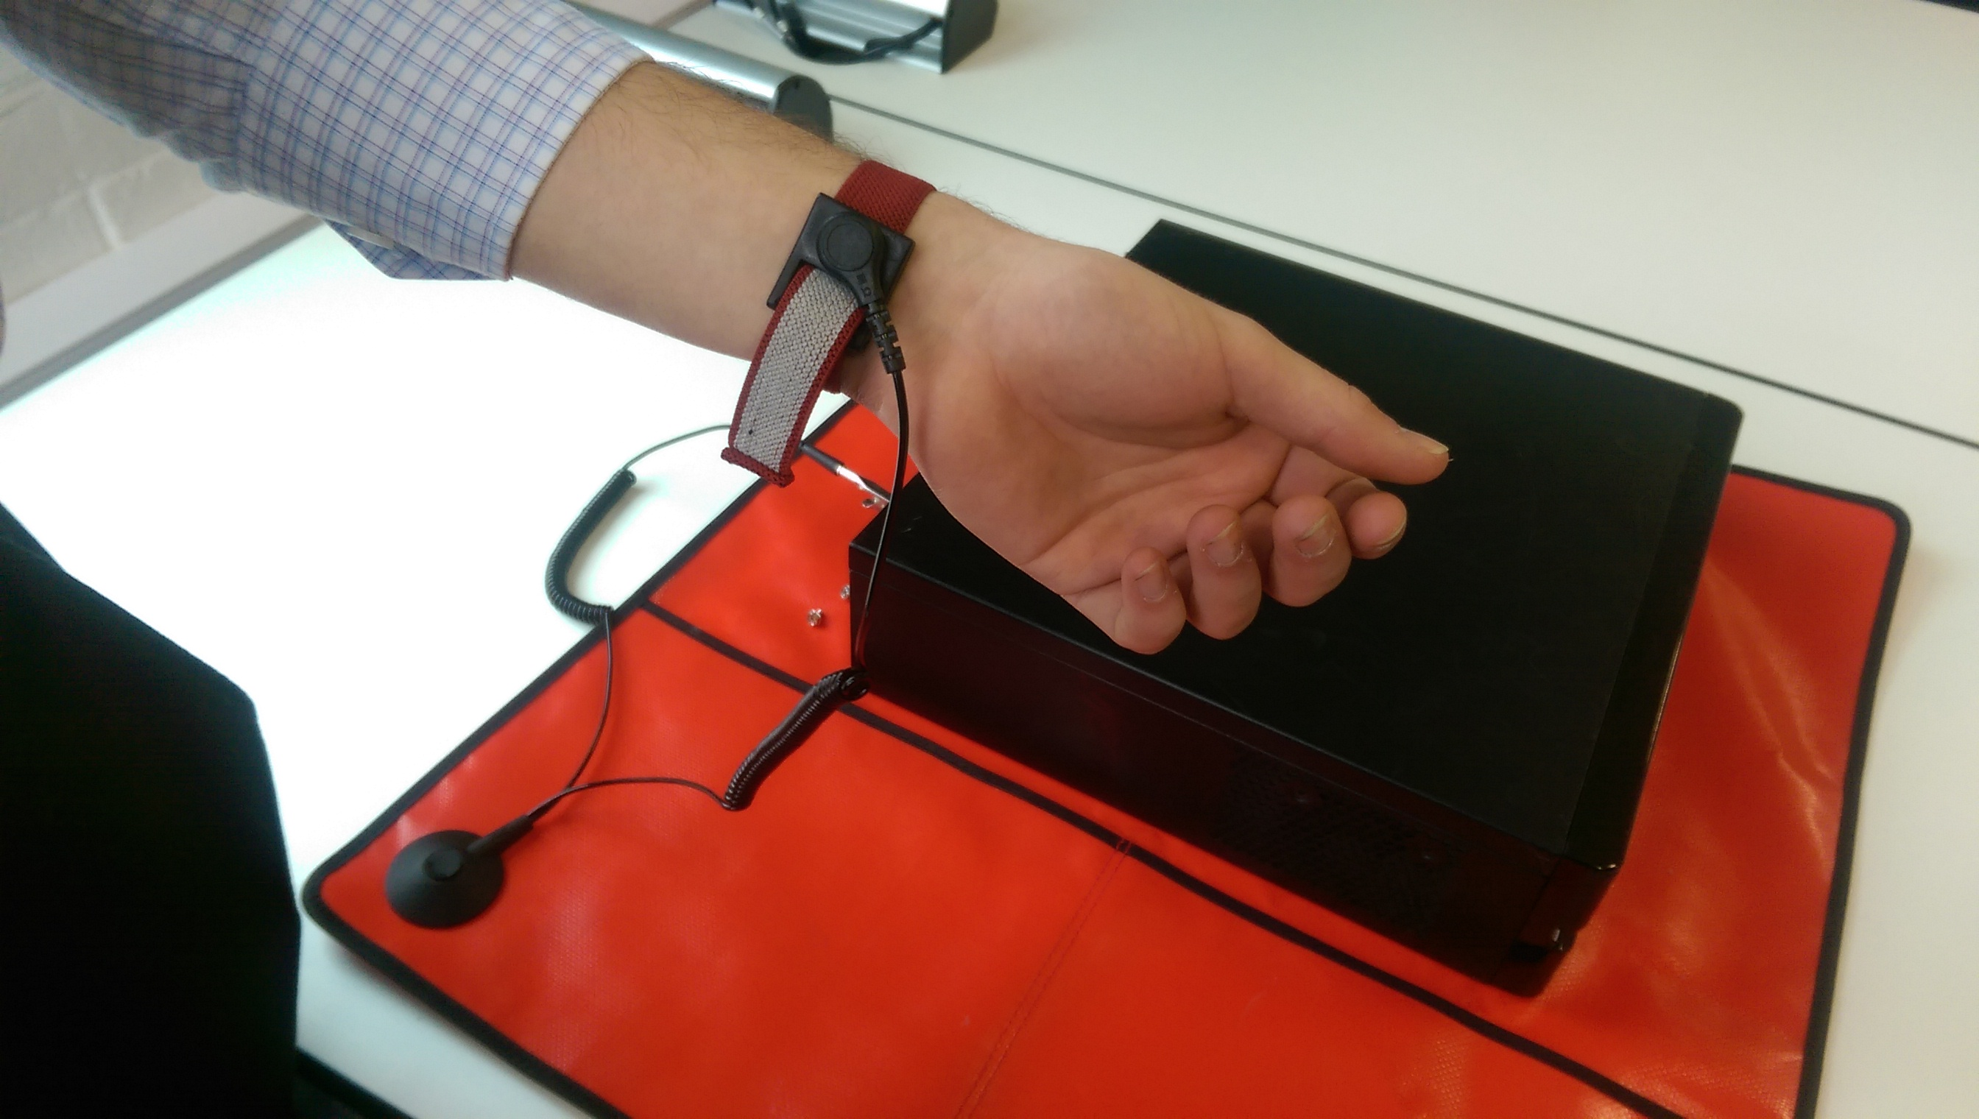

# PV – Good Working Practices

When performing the maintenance on the four machines we were given, we had to use good practices at all times. This includes professionalism, such as having a clean and tidy workspace environment. We also had to have a safe workspace environment. This resulted in all of those working on a machine to take off their lanyards and ties when performing maintenance. This meant that we would not hurt ourselves whilst working on the machines, as the ties and lanyards may get caught on the machinery. If there was a danger in the room our ties and lanyards may slow down our getaway from the area, resulting in physical or psychological damage. Our lanyards and ties may also get caught in the moving parts of the system, meaning that we could get strangled, possibly resulting in death. Our ties and lanyards could also burn if there was a fire, resulting in severe burns if they could not be removed in time.

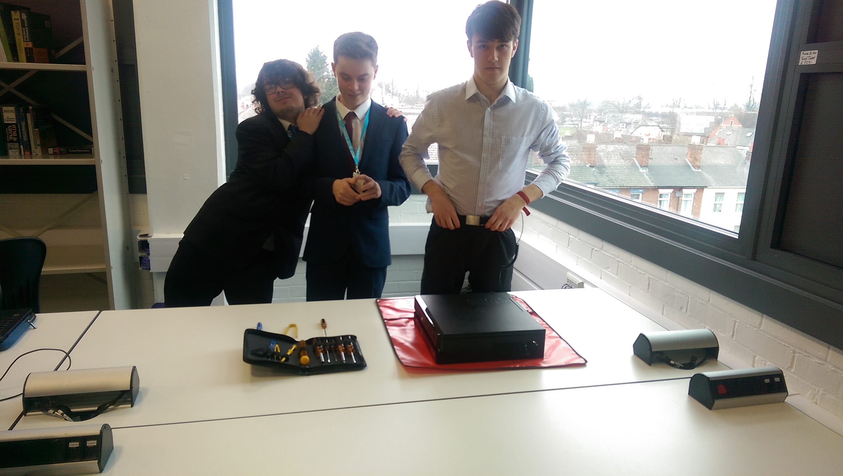

Having a clear desk does not only create a professional environment, it also prevents possible safety risks. If the desk was not clear and had sharp objects on it, if we were to fall onto the aforementioned sharp object we may have hurt ourselves. We also used an electrostatic discharge mat and the accompanying wristband when working on the computers. This prevented electrostatic discharge damaging the internal components of the computers. It also prevented electric shocks from the mains power caused by touching the metal parts of the computer that were connected to the live cable plugged into the wall socket.

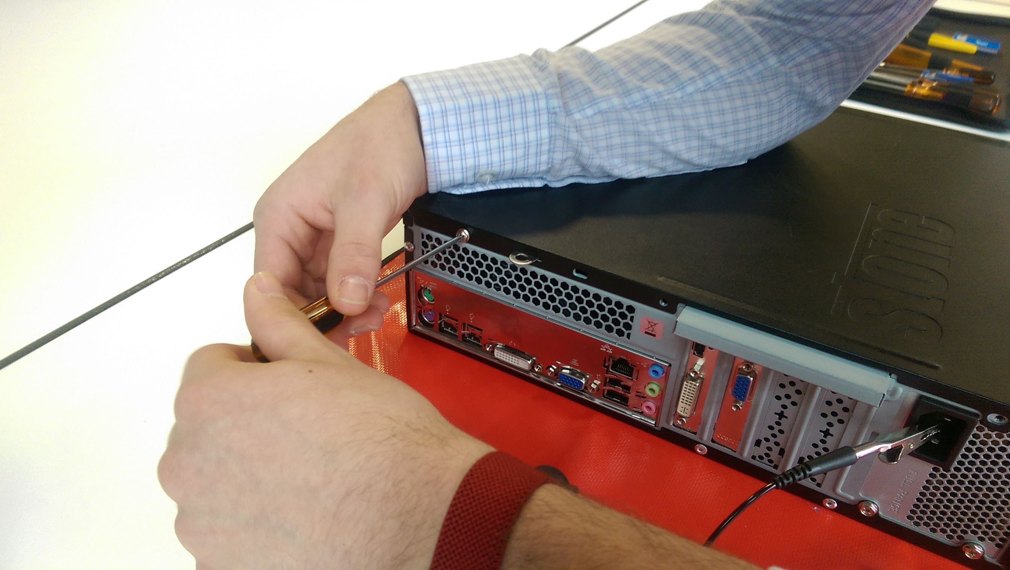

# PVI – Recording Fault Diagnosis & Repair Activities

|  |  |  |  |  |
| --- | --- | --- | --- | --- |
| Fault number: | PC #1 | | | |
| Type of problem: | Hardware | Software | Networking | User |
| Yes. | No. | No. | No. |
| Problem: | Error code 2 beeps, no RAM detected | | | |
| Serial number: | J88KJ-PGWH-3V87B-27R3B | | | |
| Make: | Stone | | | |
| Is the unit connected to power socket? | Yes. | | | |
| Is the unit secured? | Yes – on an ESD mat | | | |
| Is the unit complete? | Yes. | | | |
| Does it power up? | Yes. | | | |
| Does it get past POST? | No, it beeps twice. | | | |
| BIOS Settings: | Could not find out. | | | |
| Does it boot into the operating system successfully? | No. | | | |
| Operating system and version: | Windows 7 Home Premium. | | | |

This error that we discovered was quite serious as without RAM a computer cannot function. Luckily, it does not take much knowledge of computers to know how to fix the RAM so that it will be accessed by the machine. These errors can be avoided in the first place if the manufacturers placed the RAM in correctly and made it so that the RAM would not become easily dislogged. An example of fixing this would be to glue the RAM in place, but this could mean damage to the system if the RAM needs to be upgraded to be compatible with technological advancements.

|  |  |  |  |  |
| --- | --- | --- | --- | --- |
| Fault number: | PC #2 | | | |
| Type of problem: | Hardware | Software | Networking | User |
| Yes. | No. | No. | No. |
| Problem: | Error code 99, power supply failure | | | |
| Serial number: | 68985W2J | | | |
| Make: | Stone | | | |
| Is the unit connected to power socket? | Yes. | | | |
| Is the unit secured? | Yes, the unit is secured on an ESD mat. | | | |
| Is the unit complete? | Yes. | | | |
| Does it power up? | Yes. | | | |
| Does it get past POST? | No. | | | |
| BIOS Settings: | We weren’t able to get into the BIOS. | | | |
| Does it boot into the operating system successfully? | No, we weren’t able to get into the operating system. | | | |
| Operating system and version: | We could not check. | | | |

This issue was very serious as it meant that the computer couldn’t function at all. In the worst case scenario, the machine could cause a fire as the power supply unit was broken. This could be avoided if the manufacturer had better quality control, meaning that there would be less mistakes when creating their products.

|  |  |  |  |  |
| --- | --- | --- | --- | --- |
| Fault number: | PC #3 | | | |
| Type of problem: | Hardware | Software | Networking | User |
| None stated. | No operating system. | None stated. | None stated. |
| Problem: | The unit did not have an operating system. | | | |
| Serial number: | 6898W2J | | | |
| Make: | Dell | | | |
| Is the unit connected to power socket? | Yes | | | |
| Is the unit secured? | Yes – it is on an ESD mat. | | | |
| Is the unit complete? | Yes. | | | |
| Does it power up? | Yes. | | | |
| Does it get past POST? | Yes. | | | |
| BIOS Settings: | Stone BIOS v2.2.0. No updates are required. Dell motherboard. | | | |
| Does it boot into the operating system successfully? | No – the unit does not have an operating system installed. | | | |
| Operating system and version: | None – there was no operating system installed. | | | |

This issue was not very serious. Installing an operating system is a relatively easy fix. This issue could have been avoided if the user had not deleted their operating system.

|  |  |  |  |  |
| --- | --- | --- | --- | --- |
| Fault number: | PC #4 | | | |
| Type of problem: | Hardware | Software | Networking | User |
| No. | Yes. | No. | Yes. |
| Problem: | The computer had no anti-virus software | | | |
| Serial number: | CNX91309L3 | | | |
| Make: | COMPAQ | | | |
| Is the unit connected to power socket? | Yes. | | | |
| Is the unit secured? | Yes. | | | |
| Is the unit complete? | Yes. | | | |
| Does it power up? | Yes. | | | |
| Does it get past POST? | Yes. | | | |
| BIOS Settings: | The BIOS was fully working. | | | |
| Does it boot into the operating system successfully? | Yes. | | | |
| Operating system and version: | Windows 7. | | | |

On the surface, this issue was not severe. Under the surface, this issue could have been very severe due to the fact that some very dangerous viruses could have been installed on the operating system. This could have been avoided if the user had decided to install Windows Defender along with their copy of Windows, as the operating system prompts you to do when you first install it.

# MI – Effective Communication with Users During Fault Diagnosis

**PC #1 Communication**

*\*Walks to centre room and takes PC to desk\**

Brett: Let’s plug it in and see what’s wrong

*\*Plugs in PC to power and screen. PC beeps loudly twice\**

Brett: Hmmm, that doesn’t seem right

Will: Yeah, let’s try that again and make sure all the connections are in place

*\*Re-plugs in all of the cables. PC starts up and beeps twice loudly\**

Dan: Okay, Nathan can you look up what a 2 beep error code is on a stone machine while I start opening it up

*\*Starts opening PC whilst keeping to all the safety procedures\**

Nathan: Having a look online, 2 beeps seem to indicate a RAM problem and you should reseat it or replace it

Brett: Cool, let’s try reseating the RAM then

*\*Reseats RAM\**

Brett: Okay, the RAMs re-seated, hopefully that would have solved it

Will: Let’s turn it on then

*\*Replots in PC and starts it up PC beeps loudly twice\**

Nathan: Maybe would should try placing the RAM in the other slot as that could fix it

*\*Unplugs PC, inserts the RAM into the other slot and re plugs in the PC\**

Dan: Alright, let’s try that then

*\*PC starts up and beeps twice loudly\**

Brett: It must be that RAM stick that’s has died, how can we fix that

Will: We can just grab another stick from another machine right

Nathan: Yeah, let’s do that

*\*Takes some working RAM from another machine\**

Nathan: Here I found some new RAM  
Dan: Great, let’s plug that in then and it should work fine so long as the motherboard is working then.

*\*Unplugs the PC and installs the new RAM and re-plugs the PC in\**

Dan: Alright let’s try this

*\*Turns on the PC. PC boots up perfectly\**

**PC #2 Communication**

Brett: Get the next PC from the centre room and get a different make from the one we have already.

Nathan: I’ll go and get it.

*\*Walks to centre room to grab PC\**

*\*Walks back and places PC on the desk\**

Dan: I’ll plug in the computer.

Will: Cool. Cool cool cool.

*\*Connects power cable to the monitor and desktop, connects monitor to the desktop with a VGA cable.*

*\*Turns on PC\**

*\*Waits for the PC to get into BIOS and then error code appeared in the bottom right of the monitor\**

Dan: An error code has appeared in the bottom right of the monitor, the error code is 99.

Brett: Ok, Nathan and Will check what error code 99 means.

Will: Will do.

Nathan: Alright.

*\*Logs into laptop and loads up Google Chrome to check what error 99 means\**

Will: Error code 99 is a fault do with the power supply.

Brett: Right, let’s open up the desktop and check if all the cables are plugged in properly.

Will: I’ll clear the desk so we have space to work on the computer.

*\*Clears desk\**

*\*Unplugs PC\**

Nathan: I’ll check inside the PC.

*\*Checks inside PC to make sure all cables are plugged in correctly\**

Nathan: Right I have checked inside the PC and everything is plugged in correctly.

Dan: Now we should plug the desktop back in and see if the error code appears.

*\*Plugs everything back in again\**

*\*Error code appears again in the bottom right hand corner of the monitor\**

Brett: Well the only option we have is to send the desktop off to a company to get it fixed.

Will: Agreed.

**Unit #3 Communication**

*\*Will & Dan go into the cupboard where all of the computers are stored. They pick one at random and carry it out to the operating table\**

Will: Alright… *\*reads description taped to the side of the unit\** This computer is apparently not booting up at all. The user who used the machine said that they didn’t know what to with it, so they left it to us to repair it.

Dan: Any more information, other than that it didn’t boot up?

Nathan: Yeah, it seems a bit vague.

Will: Uh… Nope. Nothing other than ‘it won’t boot up’.

Brett: That’s not very descriptive. Users. *\*tuts\**

Dan: Let’s plug this in and see what the issue is.

*\*Brett reads what model it is, then goes back into the cupboard and pulls out the required power cable, making sure that the voltage, amps and physical connector are all compatible with the unit. \**

*\*Nathan plugs the wire into the mains and B plugs the other end into the unit. \**

*\*The unit starts to load up, but produces two short but only loads up into the BIOS. After further inspection, the unit then doesn’t have an operating system installed. \**

Will: No operating system, huh? How could someone mess up *that* badly?

Dan: I don’t know. Let’s take a look at the email and see what OS the user originally had on this computer. Brett, could you look that up?

Brett: Sure thing.

*\*After a few minutes of searching through his email archives, Brett discovers that the user had a copy of Windows 7 installed on the machine. Upon the discovery of this information, Nathan goes to the cupboard and searches for a USB with a Windows 7 ISO on it. He plugs it into the machine. \**

*\*Dan repeatedly presses F2 and F12 in order to get to the BIOS. Upon activation of the BIOS, he chooses to run from USB. \**

Brett: Aright, this should boot up from Windows.

*\*After waiting for a few minutes, a prompt comes up asking what the computer’s name should be. Dan fills out the form with the original user’s name and other data, and then installs Windows via a recommended version of Windows. \**

Nathan: And now, we wait.

*\*The team work on other computers while they wait for Windows to fully install. 30 minutes pass and the system finally installs. \**

Will: Hurray, it’s finally installed. Let’s send it back to the original user.

*\*The unit is packed and shipped to the owner\**

**Unit #4 Communication**

Will: I’ll get the next computer to work on.

*\*Gets a different computer and puts it in our work area\**

Dan: Shall we see if it works.

Brett: Good idea.

*\*Connects power to the PC and connects it to a monitor with a VGA cable. PC boots up and loads Windows\**

Nathan: It was a bit slow booting up.

Will: That could be a problem, let’s try test some programs to see if anything else happens.

Brett: What should we try first?

Dan: Let’s try some simple programs like email and word.

*\*Opens outlook on the computer\**

Dan: There’s emails here that shouldn’t have been sent, it looks like there must be a problem.

Will: I wonder what the problem is, it’s hard to tell.

Brett: Let’s try test the computer with other programs.

Nathan: That’s a good idea, it might help us work out what’s wrong.

*\*Closes outlook on the computer\**

Brett: Somethings happened, loads of ad banners are showing up on the computer.

Dan: Someone must have hacked the computer or put some program on it that’s doing this.

Will: It looks like the computer has a virus.

Nathan: I agree, let’s check with someone more experienced.

*\*Speaks to IT technician about the problem\**

Nathan: They said its most likely a virus

Will: Okay let’s install some anti-virus software to fix the problem.

Brett: Okay good idea, there’s plenty of free pieces of software on the internet.

*\*Opens up internet and installs anti-virus software\**

Dan: Right let’s do a full scan of the computer that should find it and delete it.

*\*Runs full virus scan\**

Will: It’s found the virus and removed it.

Nathan: Let’s check that there’s no other problems.

*\*Checks the computer for other problems, determines that computer is fully functional\**

# MII – Justification of Appropriate Remedies During Fault Diagnosis

To solve the hardware based issues that were brought to us with the first, second and third units, we used an electrostatic discharge mat that allowed us to access the system without hurting both ourselves or the components inside the computer. We also used the accompanying wristbands to redirect all of our static energy away from the components that we were handling and into the electrostatic discharge mat. For the first system we also used a screwdriver and a voltmeter as we could not get past POST due to a power supply failure that we could not fix. We used a screwdriver and tweezers for the third machine as we had to remove and replace the RAM due to the RAM error it produced when being started up. The fourth unit did not have any hardware faults.

To solve the software based issues that were brought to us with the second unit, we used the Windows Installer from the ISO that we had on the USB drive that we found in the cupboard. The following images show Windows being installed on the system. To solve the software based issues that were brought to us with the fourth unit, we installed Malwarebytes via the Malwarebytes installer that we found on <http://malwarebytes.com/>. We also used Internet Explorer to access this webpage in the first page. The first and third units did not have any software faults.

The first thing that we did to make sure that we were safe was the removal of our ties and lanyards. This meant that we would not hurt ourselves whilst working on the machines, as the ties and lanyards may get caught on the machinery. If there was a danger in the room our ties and lanyards may slow down our getaway from the area, resulting in physical or psychological damage. Our lanyards and ties may also get caught in the moving parts of the system, meaning that we could get strangled, possibly resulting in death. Our ties and lanyards could also burn if there was a fire, resulting in severe burns if they could not be removed in time.

The second thing that we did was we ensured that the desk was clear from any and all things that could cause both a distraction and an unsafe work environment. This allowed us to work in an environment that would allow a highly safe environment. If the desk was not clear and had sharp objects on it, if we were to fall onto the aforementioned sharp object we may have hurt ourselves, resulting in a less productive and hostile workplace environment.

The third thing that we did to ensure that we would be safe during the process of fixing the computers was it use an electrostatic discharge mat and accompanying wristband to prevent electrostatic discharge and to also prevent electric shocks from the mains power caused by touching the metal parts of the computer that were connected to the live cable plugged into the wall socket. If this were the case, we would probably not survive the 3kW that comes from those sockets. Another reason as to why we used an electrostatic discharge mat was to ensure that none of the components inside the machine were broken by the static discharge given out by our bodies.

We used a rather complex solution with many steps as the problem that we were tasked to solve was also complex. Therefore, a solution with many steps was required in order to solve the issue at hand with maximum efficiency with minimum risk. I justify the actions that we did for the main reason that they are tried and tested reasons of keeping computer repair people safe from harm. There is a reason that electrostatic discharge mats are easily available from multiple suppliers around the world, and that is because they have been confirmed to move static generated by humans away from the delicate components inside computer systems, resulting in expensive components not being damaged by static discharge.

# MIII – Maintaining Data Security & Integrity When Applying Remedies

Data security and the integrity of the system are important things to think about when applying remedies to the machine. If the data on the system is not secure, or the integrity of the security systems are not intact, then data could be lost or stolen by outside parties. This could mean that trade secrets, bank details, medical information or confidential emails could be leaked, either to an opposing business or to an internet forum, where the data would be available to all to see, if they had the correct search terms in place. This type of information can break companies and can ruin business empires. A good example of this is the Showcase email leak that happened in November 2014. This leak happened because Sony were going to release a movie called *The Interview*. In this movie, the North Korean leader Kim Jong-un is mocked repeatedly. A hacker group, called the Guardians of Peace, released a massive amount of confidential data taken from Sony’s databases, the amount was claimed to be over 100TB of data, but this information is unverified. Some of the data included personal information about the Sony management and their families, employee salary and unreleased movies. The total cost of these damages is estimated to be $15,000,000. While this may have been one of the more extreme cases of data leaks and a lack of security measures, it shows that it is important to keep all of your data safe.

When performing an upgrade to the system or routine maintenance to a system, it is important to keep a backup of all files stored on the system, just in case the system goes down for an extended period of time, or if it crashes completely, then all the data on the system could be lost. If there was a choice between losing all the data on the system, or waiting an extra hour to copy over all the files, the latter of the two would be the obvious choice.

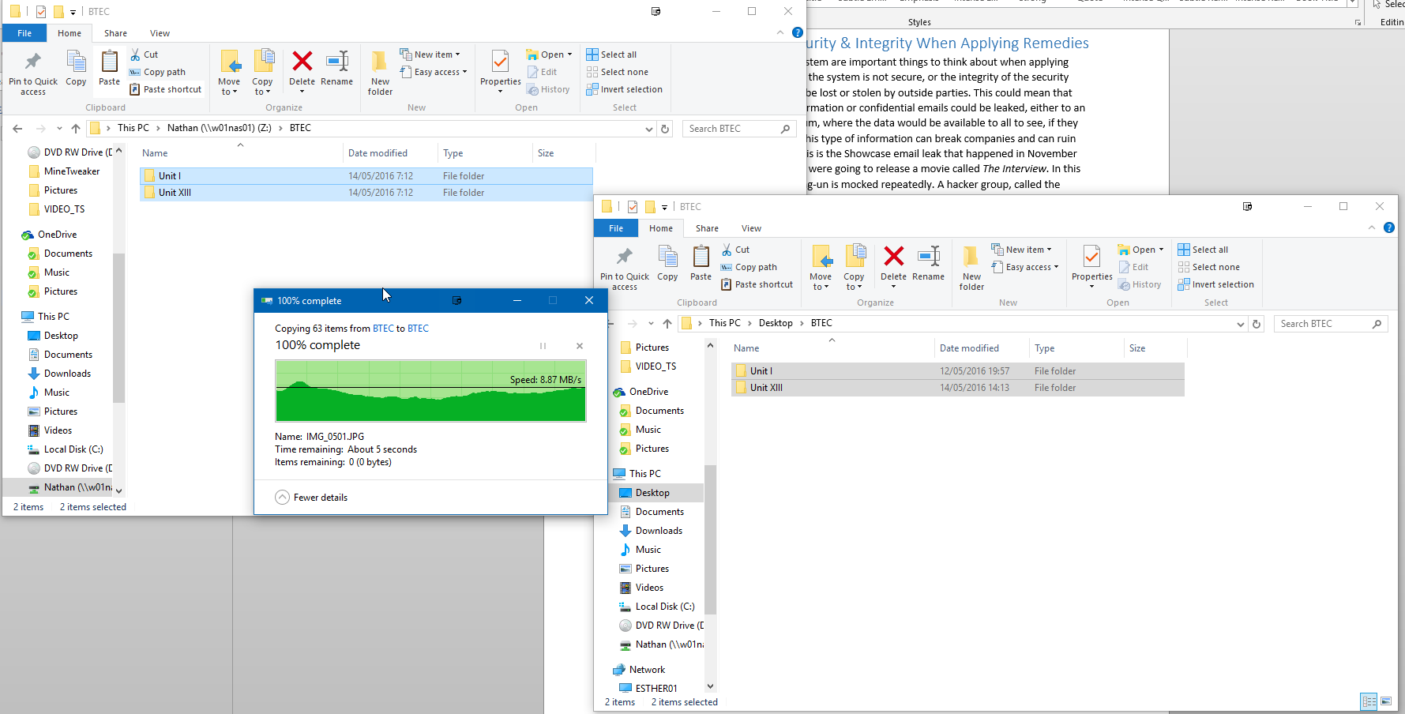

The integrity of repairing computers is an important one. If the integrity of data protection is broken, then there may be repercussions for a company, including loss of customers or even law suits. The reason behind the former of these two points is that if word spreads that a company has a bad standard when it comes to data protection when they are a computer maintenance company, customers will avoid that company’s services due to its bad reputation. This can lead to lower profits, redundancies and maybe even bankruptcy, due to a lack of income that used to be generated by customers, but given that there are many less customers than before, the amount of money a company makes will shrink rapidly. If a company is sued and the case is dropped, the witnesses refuse to testify or thrown out of court then the business will still lose money due to the cost of lawyers and the time off that certain employees will require to assist the case. If the business loses the course case they will lose a lot more money that if the case gets thrown out, and they may even have to declare bankruptcy. If the business wins the case due to either insubstantial evidence or if the law suit was incorrectly filed, then the business may gain money. That being said, if they do actually have a bad attitude to data integrity, the chances of them actually winning a law suit is very slim.

# DII – Comparing Hardware & Software Troubleshooting Tools

When troubleshooting, I would rather use Tweezers over Pliers, due to the fact that Tweezers are more precise instruments. I would consider Pliers a tool for bigger jobs such as large electrical circuits that require brute force rather than careful movements. Pliers are normally considered to be similar to wire cutters, and are normally used from removing things, whereas Tweezers are used for correcting things.

I would rather use the Claw than my hand when picking things up from inside the computer for the main reason that the Claw is much more precise and can pick up things from a distance with ease. The Claw also minimises the risk to my hand as if there were a malfunction in the system that caused the fan to spin up while my hand was inside it, serious damage could be caused.

Depending on what machine I was working on, I would have to choose between a Flat Headed Screwdriver and a Philips Screwdriver. If I did not know what types of screw the machine has, or if it had a mix of both Flat Head and Philips Screws I would use a Flat Head Screwdriver as it can technically be used on both. If the machine used just Philips Screw, then I would use a Philips Screwdriver. Overall, a Flat Head Screwdriver is better due to the fact that it is universal.

From the software side of things, if I had to choose between Windows Defender and Malwarebytes, I would choose Malwarebytes as it has constantly proved that it is better than Windows Defender. If I could use both though, I would. It is always better to have two safeguards over one, even if one of the safeguards is so good it should mean that the other is never used. I would recommend using both if you can, but Malwarebytes is definitely better than Windows Defender.

# Bibliography

* Basic Information – BTEC IT Level 3 Book.
* Sony Hack Information – Wikipedia & BBC News.
* Other Information – Various Internet Sources and my Lecturer.
* Money Graph (MIII) – [123rf.com](http://123rf.com)